Solar Sailing and solar power-Generation by “Roller-Reefing” - a Design paper - of a Demonstrator solar sail power station Spacecraft (SSPS)

Frank Ellinghaus
(independent inventor)

Abstract
Roller Reefing is an enabling technology that combines solar sailing and space based solar power generation with fuelless high precision attitude control and station keeping. It allows the on orbit construction of very large solar spacecraft, as well as the direct launch of smaller solar sail power stations (SSPS) with relative large solar cell arrays.
This paper presents the design of a direct-launch-able solar sail spacecraft that could be used as a space-based solar power station and proposes a way to operate it as a movable spacecraft in a geostationary orbit (GEO).
It is based on the Solar-Sail-Launch-System (patented in Germany and UK, patent application pending in the US). A modified System-Sail spacecraft of the Launch-System will be used as a space based solar power station and might serve as a demonstrator for larger units.
INTRODUCTION
In 2009 PG&E, a large California power utility company and Solaren Corp. completed a contract, that would allow Solaren to deliver beamed energy from space to the companie's facilities for a fixed price. This contract has been approved later by California regulators. Similar plans are also established by JAXA and a private coalition.
Besides technical challenges, financing is a major hurdle to this ambitions, since huge - kilometer-sized space constructions would have to be assembled in and tons of materials launched to space - a multi billion dollar adventure. It would be hard to convince investors to provide such a huge range of financing before the viability of the project is proven. Since Solaren has announced the power supply by 2016, a demonstrator craft, which costs "only" multi millions of dollars is needed very fast.
This could become a chance for the construction of a space based solar power station which is also a solar sail spacecraft. While solar sailing already lost out to solar-electric propulsion because for the mission(s) in question reaching the destination with the proven thruster technology was assumed to be faster and cheaper. In the following design, the craft does not need to reach GEO with the help of solar sailing technology. Solar sailing would just be used for fuelless station keeping and fuelless high precision attitude control. Something, solar sailing could do best of all known propulsion technologies.
Solar electric propulsion cannot be fuelless and the author of this paper thinks, that attitude control and station keeping will also be smoother and less prone to failure if the optimal steering -strategy and -programs are found.
Later when handling and control of SSPS are better known, those power stations could become mobile as well and find a further usage as mother ships and power stations for asteroid prospector and mining missions.
A SSPS in GEO with it's solar sailing technology could provide the ability to develop solar sailing strategies by using remote control under a small time lag with sufficient funding while financing more complex solar sailing missions without power station features would bump on serious financial hurdles. The solar sail as a SSPS (power station) spacecraft would not need to be launched as a piggy back payload any more, instead launching and operating it would be the main reason of the launcher mission.
Space based solar power satellites (SBPS) have to produce electricity while pointing towards Sun with large reflecting mirror or solar-cell arrays. While doing this, they will be pushed away from the Sun by at least half the thrust developed through solar sail spacecraft designed for transport purposes. They have to provide station keeping, attitude control and steering while pointing towards Sun (with mirrors or solar cell arrays for the power collecting unit) and pointing towards Earth (for the transmitting antenna or laser unit) and should preferably stay in GEO while the solar radiation pressure is pushing it.
Tons of fuel would have to be delivered to GEO if thrusters are used just to keep a large SBPS in a stable orbit and to provide pointing and steering while the spacecraft is orbiting Earth and has to change continually it's pointing direction towards Sun to stay in the GEO-orbit.
Wouldn't this be in a sharp contrast with the goal to save not renewable energy, especially when launching that fuel delivered to orbit needs even a lot more fuel for the delivery process to LEO or GEO?
Shouldn't a SBPS be designed like a solar sail spacecraft and use it's fuelless attitude control to stay in orbit gradually change the pointing direction for orbit correction instead of being intended to act like a stable space object? Wouldn't it be better to move the craft in a controlled manner instead of locking it into a fixed attitude toward Sun which along with other circumstances, like the irregular shape and gravity of Earth, would push it constantly out of the GEO-orbit?
- Roller- Reefing, an enabling technology
On Earth, Roller-Reefing is a way for sailors, to furl and unfurl sails onto and off rolls, mostly with the help of electric motors. This offers comfort and simple handling in sometimes difficult situations.
Besides fuelless attitude control and station keeping Roller-Reefing in space has even more strong advantages for SSPS-spacecraft. If the sail foils are covered with or made of roll able, thin film solar cell arrays, the same equipment could be used for both, fuelless steering and also for energy collection.
Therefore the solar sail/solar cell arrays for both uses will be labeled as solar foils in this paper.
Construction and solar foil setting would be extremely simplified through splitting large solar foil arrays into umpteen foil panels furled onto rolls which are just mounted to their roll holder brackets on the outer rim of the spacecraft structure.
Sail or in this case solar cell array setting happens by smoothly unfurling the flexible solar cell panels off their rolls.
The construction of large space mounted power stations and also the deployment of Earth-launched solar power stations could happen in Low Earth Orbit (LEO) while the sail would not be set until the point or orbit of service is reached.
By furling the foils back onto their rolls reefing sails/ solar cells and getting back to LEO without disproportionally large atmospheric disturbances would be possible.
Replacing heavy stiff solar cells through lightweight thin film solar cell arrays would reduce the mass and with it the launch costs of an SSPS significantly.
Maintenance and upgrade of the spacecraft could be simplified through the possibility to re furl and change furled rolls easily. Especially for solar power stations, which are meant to serve for long periods, this is an important advantage which would reduce operating costs considerably.

Fig. 1. Solar sail and solar thin film cell foil on a roll
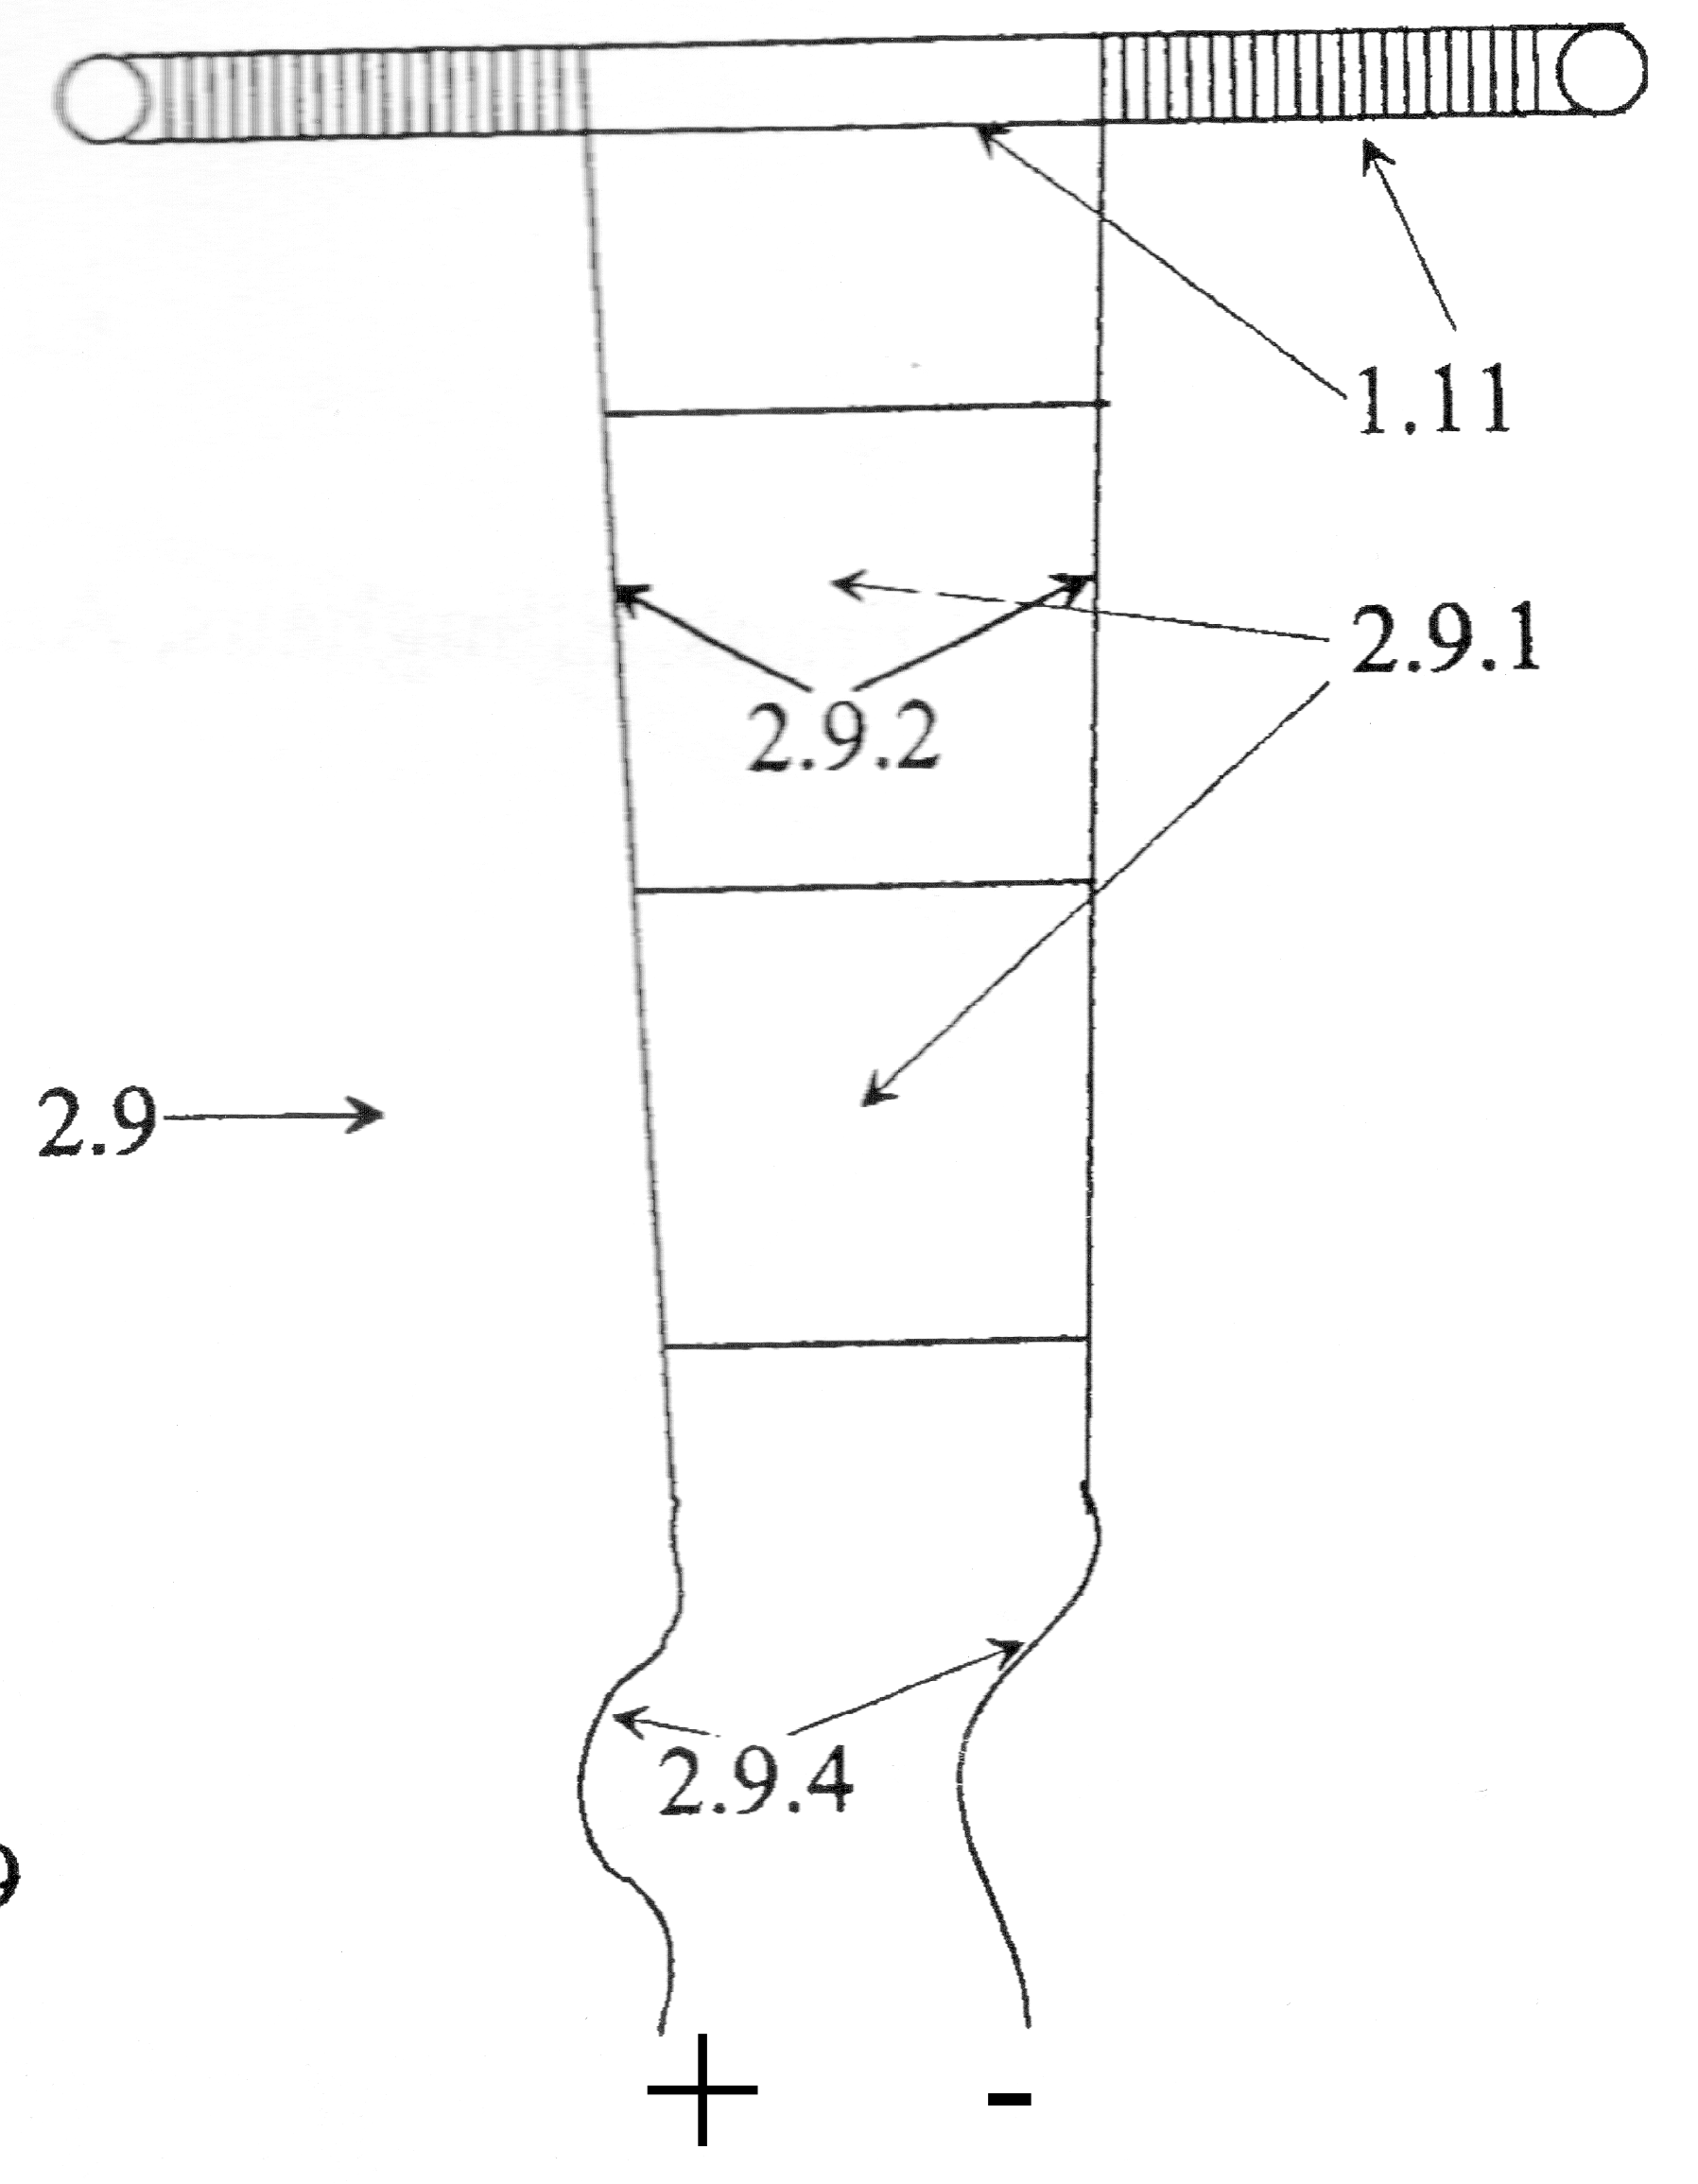

Fig. 1 shows the solar sail/ solar cell foil 2.9 partly unfurled on a roll 1.11. The solar foil rolls are held on the outer edge of the spacecraft and are driven by electric motors. The side and end threads take the load when the electric motors built into the rolls pull the foils/arrays toward the power stations outer edge for reefing, or when winches located near the center of the craft pull the end threads for setting the solar foils. Having the motors always slightly pulling, the tension would keep the solar foils wrinkle free. The threads would also serve as electric power lines. Preferably they are made of isolated carbon nano tube material
because of it's excellent space hardiness and the good electric conductivity and direct the electric power towards the center of the craft.
- Solar-Sail-Launch-System
The SSPS-design is based on the Solar-Sail-Launch-System, consisting of the System-Sail mothership spacecraft and the System-Launcher. Initially the mothership is latched in a stowed position to a rotation platform in the launcher's payload compartment. The solar cell foil rolls are mounted to the tips of telescopic masts, which are tilted upwards during launch. Daughter units are already docked inside the mothership's central docking- and payload station. This docking-station is surrounded around it's middle by a plane layer of connected rings which serve as holding structure for further spacecraft equipment and gear, like thruster units, computer units, a bus-system and already mounted solar cells.
Fig. 2 System-Sail/power station mothership spacecraft in launcher
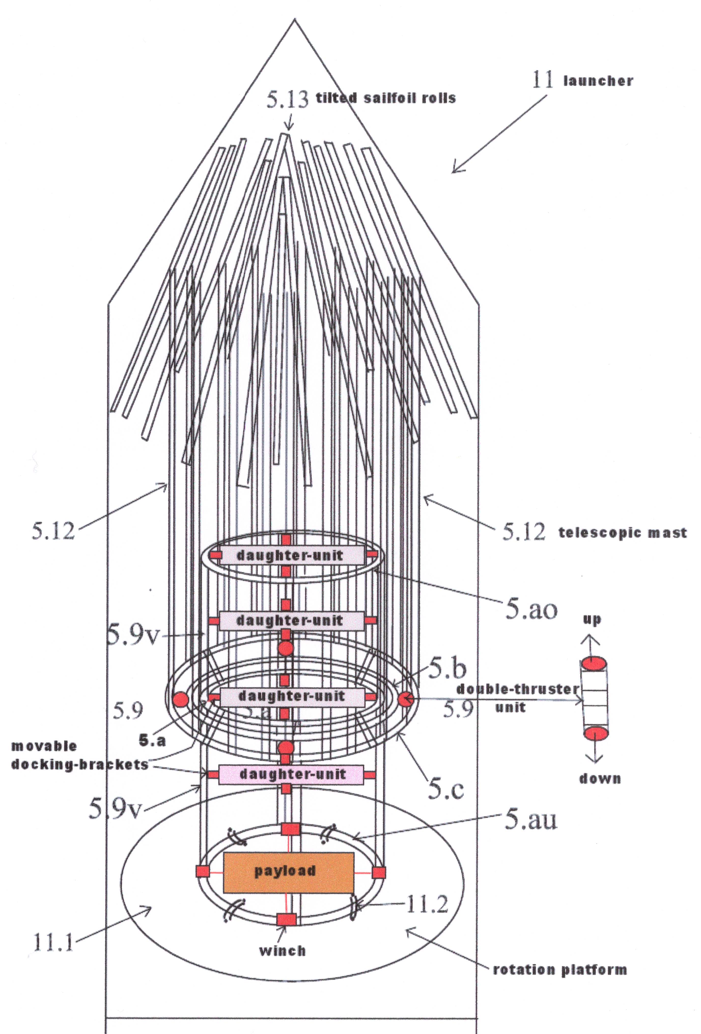
Reference Design for
Ariane V ™ ECA

Solar Foil area = 3120 sqm
(more than the solar
cell-arrays carried by
the ISS)

12 seven segment masts,
each about 70 m long,
with solar foils of about
260 sqm each.

Volume of docking-
station = 28 cbm

area of additional gear-
plane = 12,4 sqm
x 2 (above and under
the plane = 24,8 sqm)

Daughter units could serve as beaming parts of the power station. They would be independent spacecraft, but also connected with power cables to the System-Sail spacecraft and transfer the electric power by pointing and beaming towards Earth. To investigate both beaming possibilities, at least two beaming units, one equipped with laser- one with microwave technology would be carried inside the docking station.
The power cables would prevent conversion losses and are just the simplest way to do a demonstrator mission.
Further daughter units can and should be carried with the mission for observation and telecommunication.
This would enable visual tele-operation by photo and video data and a thorough analysis to develop the needed knowledge and strategies to steer and operate larger solar power stations also.
Those daughter units without power connector cable would be able to dock back into the mothership to recharge their accumulators.
2.1 Deployment
As the SSPS features solar sail capability and ion thruster propulsion, it can be launched besides to GEO also to low Earth orbit (LEO). The sail foils wouldn't be set until the influence-zone of the Earth-atmosphere is quitted. This possibility enables to squeeze launch costs one more time considerably.
When the point of service or destination orbit is reached, the launcher opens up like a flower, through a payload compartment hull which consists of a plurality of petal-like segments, corresponding in number to the number of said telescopic masts of the System-Sail, and are so mounted that each can be pivoted to open the compartment and pull one of the retracted telescopic masts into a common horizontal position, where winches pull the tilted foil rolls into the right angle.
After the rotation platform starts to rotate the strapped on System-Sail spacecraft, the segments of the telescopic masts are pulled by centrifugal forces into their extended position. Once this position is reached each mast segment is held by a snap in mechanism.
The pullout-mast-segments allow to launch relative large solar cell arrays, even for Earth launched operational SSPS-spacecraft. The author has calculated a reference design with 7 segments in 12 masts. When trying to take full advantage of the volume of a heavy-lift Ariane V ™ launcher, he came to about 3.120 sqm of flexible roll able solar foil area. 3.120 sq m of solar cell area are considerable more as the ISS carries now, after long years of construction works. Since the crafts foil area would be scale able by increasing the number of mast-segments, even larger sail areas might be thinkable for direct launch.

- Attitude control system (ACS), station-keeping and propulsion
The System-Sail power station would feature several possibilities to manipulate attitude and movement:
a) Roller-Reefing by furling and unfurling of steering foils (fuelless center of mass/center of radiation pressure movement)
b) Using the ion thrusters for propulsion and attitude control with double thruster unit (DTU) configuration
c) Fuelless mass displacement through moving the daughter units with movable docking brackets
d) Fuelless mass displacement through moving payload inside the docking station with winches
e) tilting the sail foil rolls around the poles of the masts to generate or avoid rotation about the power stations plane center.

3.1 Attitude Control by Roller-Reefing
Figure 3 shows the deployed System-Sail spacecraft, in this case with 12 extracted telescopic masts and set sail foils. Four of those foils are serving as steering foils and feature ballast foils on their ends. They are designed to reduce mechanical stresses onto the delicate sail or solar cells foils and to enhance the impact of the steering forces. Therefore the ballast parts would be made of heavier and stronger materials as the regular foils. Those ballast foils only would be furled and unfurled for attitude control while the regular foils would stay principally straight.
Unfurling and furling the sail ballast panels (here ballast panels BA, BC, BD and BE) steers the sail craft through shifting the center of mass and at the same time shifting the center of light pressure into the opposite direction. In contrast to a pure mass shifting ACS this roller reefing and unfurling system adds two shifting processes for enhanced steering power into one single steering operation – (furling or unfurling the sail or ballast foil).
In this example the ballast panel C (BC) is only half way unfurled while the ballast panel D (BD) is fully unfurled, which reduces the C-foils sailing area and shifts the center of solar radiation pressure towards panel D on the opposite rim oft the craft while the center of mass is shifted toward panel C since the mass of the whole foil is shifted toward the C-foil-roll at the outer end.
In addition fine tuning the length of unfurled ballast foils, which are situated side by side to each other, enables to move the rotation axles between them. As the driving force on the spacecraft are pretty small but consistent, Roller-Reefing promises to be a high precision attitude control and station keeping system.

Fig. 3, deployed SSPS with fuelless Roller-Reefing and with double thruster units attitude control
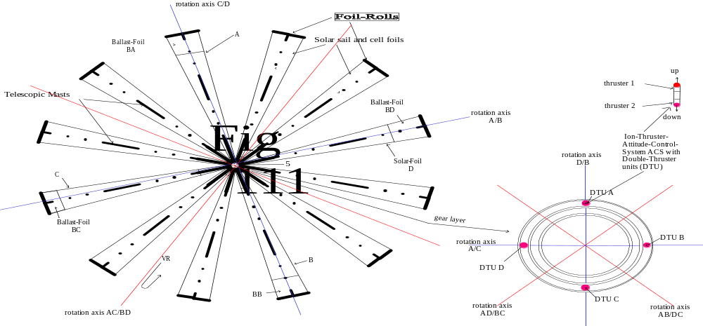

3.2 Attitude Control and propulsion by double thruster units (DTU)
Figure 3 shows also a magnified view of the equipment and gear plane layer around the central docking station with four double thruster units. Above the magnified gear plane, a magnified double thruster unit is shown. Such units feature two thrusters mounted opposite to each other in one jet tube.
This allows to slow down, stop or even reverse each move or turn due through thruster force by switching to the opposite thruster(s).
As each DTU has a partner unit placed on a diagonal line on the other side from the spacecraft center, having one thruster thrusting upwards and one of the opposite double thruster unit thrusting downwards, will result in the spacecrafts turn around a common center line. In this example with only 4 DTU's we have only 4 rotation axles. Two between two DTUs and two between two combined pairs of DTUs.
If all downward- or upward-thrusters are fired together, this will result in the plane moving upwards or downwards.

3.3 Daughter units and their attitude control
The cable bound but free flying transmission units as well as the also free flying observation and communication units would principally feature the same DTU attitude control and propulsion as the mothership. They would consist of an Outer Ring with the DTU's fixed to it. Additionally to the up and down DTU's, they could carry also at least two DTU's which are aligned parallel to the unit plane and of course again located opposite to each other on the outer rim of the thruster-ring. This would enable to propel the craft along it's plane or to turn it around it's central pole.
- Proposed Quasi stationary Operation mode of ssps in GEO
As space based solar power stations with their large solar cell arrays have to point constantly towards Sun, they will always produce thrust. Thrust which may be used to accelerate or decelerate the orbital speed of the spacecraft around Earth along with other mainly gravitational forces which would push and pull it out of geostationary orbit. It seems to be near at hand, to use the free solar radiation pressure forces to stay at least close to GEO, instead of trying to counter them by using thrusters. The idea of this proposal is, to change once a day from solar sail acceleration mode to deceleration mode and once a day the other way around. The acceleration and deceleration modes would have to cancel each other out. The spacecraft would need to stay around a GEO slot where it is allowed to move fore- and backward above Earth surface.
The spacecraft could not stay above one spot on Earth all the time but it would stay above the same point on Earth the same time of each day.

Figure 4, standard daughter unit and microwave transmitter unit
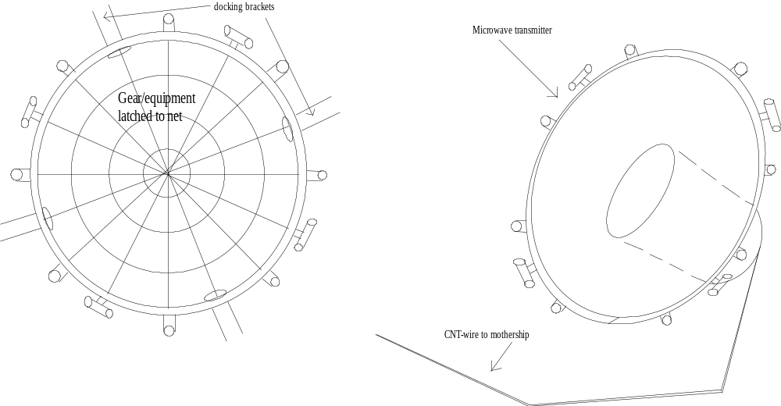
Above 2 of several possible species of daughter units with DTU propulsion and attitude control are shown. On the right a microwave transmitter unit with it's cable connection and on the left a standard unit with a plane net layer for gear and equipment fixed between the ring pipes. Further possible kinds of daughter units would be a laser transmitter, communication/observation units and container units.
Their diameter would be around 2 meters. Their area would be about 3 sq m x 2 (above and under their plane). Their Outer Thruster Rings serve also as a handle for the docking stations docking brackets.

conclusions
Roller Reefing could provide a commercial base to space based solar power production by substantially reducing launch mass, construction time in space and fuel consumption while also providing high precision steering and attitude control. The proposed design of a solar sail power station (SSPS) could serve as a demonstrator mission for larger space mounted power stations. It uses Roller-Reefing and allows to deploy solar cell arrays in one single launch, which are larger than the ISS-arrays which have been mounted in years of prolonged construction works.
Both technologies, solar sailing and space based solar power generation could profit of each other by their combination.
Acknowledgments
to the solar sail and space based solar power communities. Hopefully they will combine their work to develop a common and useful space infra structure for energy production, transportation and perhaps even mining and processing of (asteroid) materials which was the original reason to design the Solar-Sail-Launch-System.
Special thanks to Benjamin Diedrich for proof reading this paper.
References
1. Solar Sailing, Technology, Dynamics and Mission Applications by Colin R. McInnes
2. Pryor, Wie et al., “Development of a Lightweight Pulsed Plasma Thruster Module for Solar Sail Attitude Control
3. adAstra - Special Report, Space-Based Solar Power, Inexhaustible Energy From Orbit
4. US patent application 11/614,081 by Frank Ellinghaus
© Attribution Share Alike 3.0 unported

